1. Create a new web application and select [**Manual configuration** (including virtualenvs)].

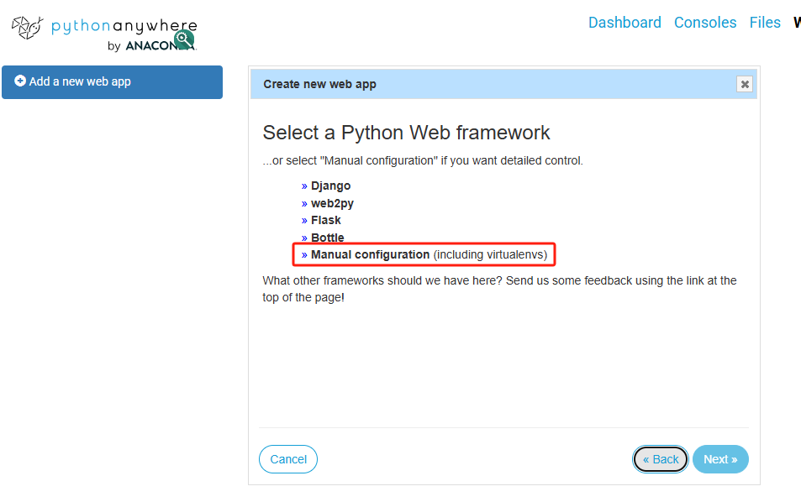

2. Select [**Python 3.12**].

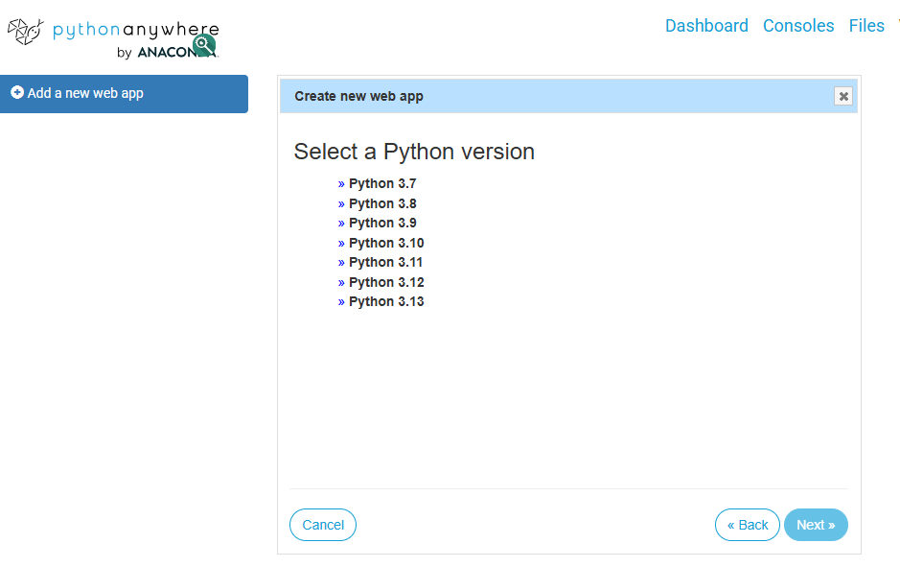

3. [Tip] Manual configuration involves editing your own wSGl configuration file under /var/www/. Usually this imports WSGl-compatible applications that you store elsewhere.

When you click "Next", we'll create a WSGl file for you, including a simple "Hello World" app that you can use to get started, with some notes on how to use the other frameworks. You can also specify a virtual environment for your application to use.

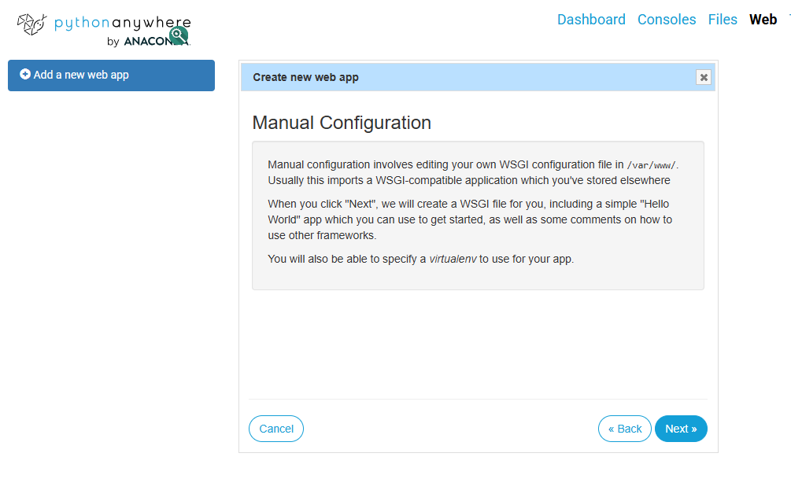

4. [Reminder] The application has been successfully deployed, and free users must return to this page to renew the free period within 3 months, otherwise they will be shut down.

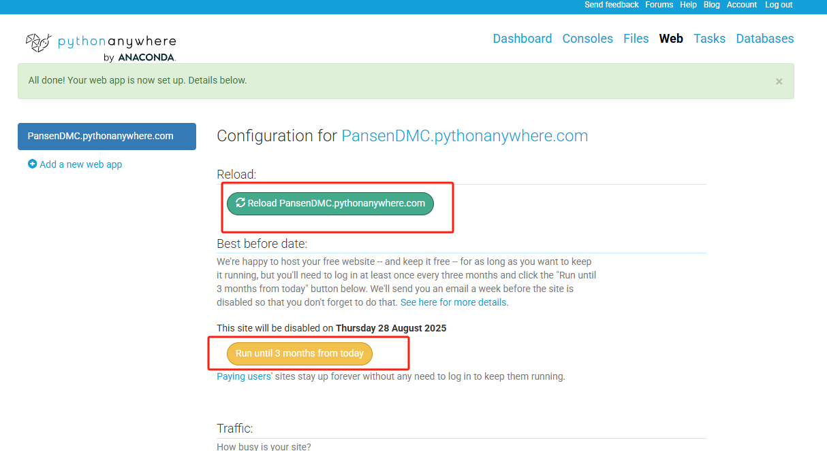

5. Click Bash to enter the terminal

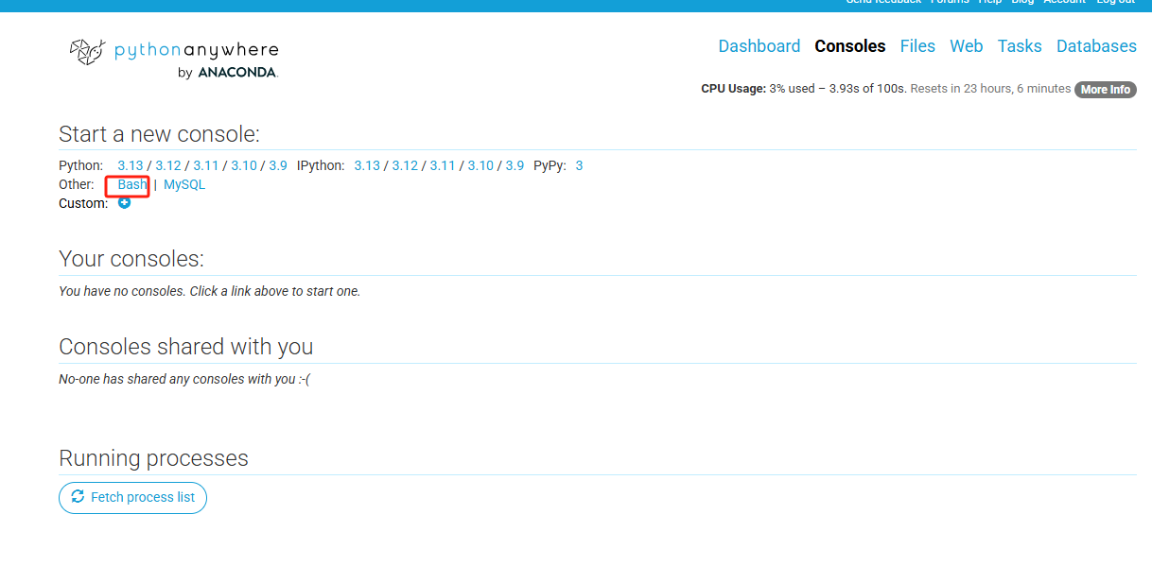

6. Clone the Github repository to the server [git clone [https://github.com/gyhongyu/Contract-Management.git].](https://github.com/gyhongyu/Contract-Management.git】)

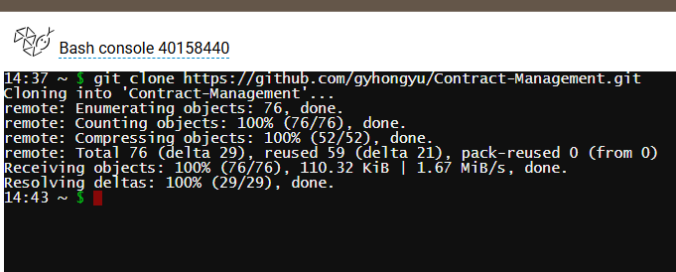

7. Create a virtual environment called Venu [python3.12 -m venv venv].



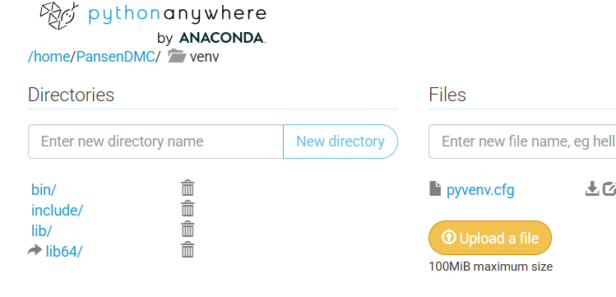

8. Activate the virtual environment [source venv/bin/activate].

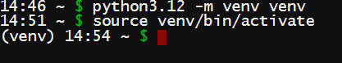

9. Switch to the dependency directory [cd /home/PansenDMC/Contract-Management] that is the same as the GitHub repository name.

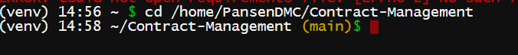

10. Install dependencies [pip install -r requirements.txt].

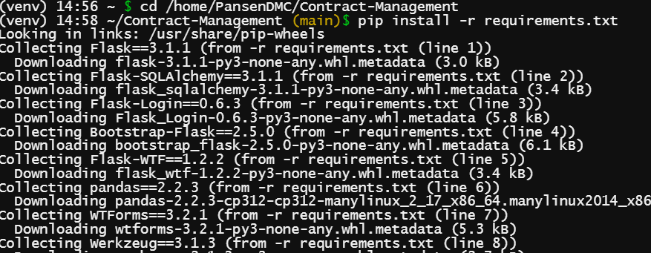

11. Go back to the web and change the Source code: to [/home/PansenDMC/venv/]; Change the Working directory: to [/home/PansenDMC/Contract-Management/], and change the virtual environment directory to the same as the Source code.

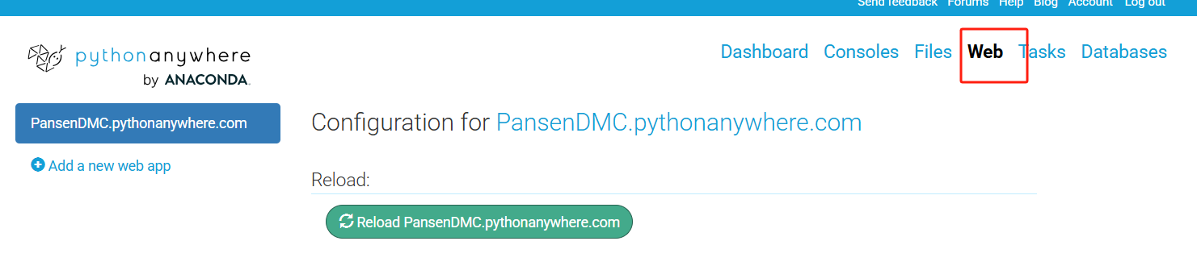

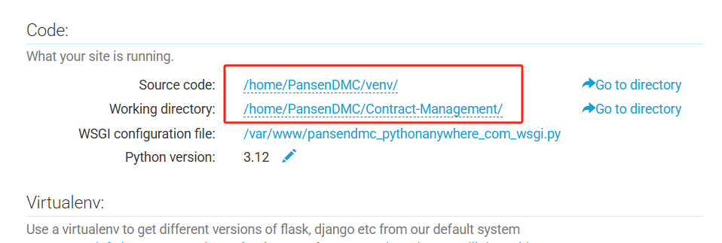

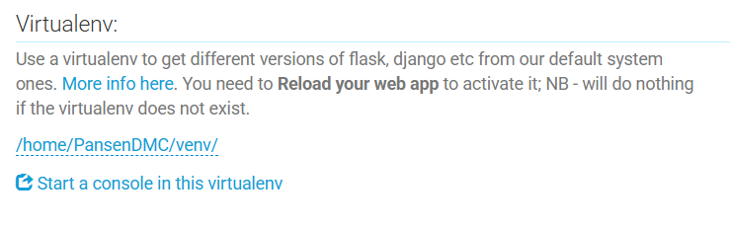

12. Change WSGI to import sys

path = '/home/PansenDMC/Contract-Management'

if path not in sys.path:

sys.path.append(path)

from run import app as application】

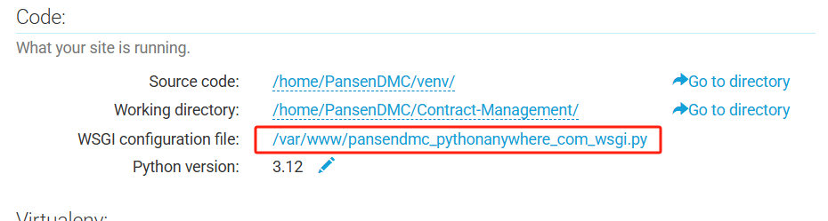

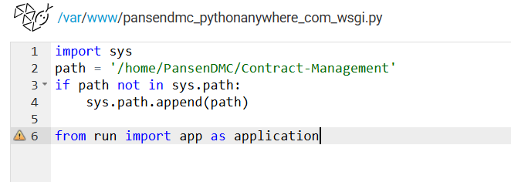

13. Save WSGI and restart the server to use

